# LCM Work Flow

**Brief:**

The LCM Provisioning workflow is illustrated in the Business Process Editor like this:

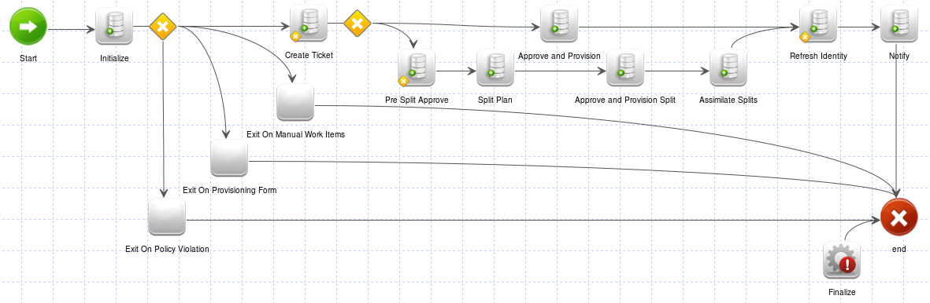

This workflow follows the full core process for LCM Workflows, which includes these key steps:

1. Initialize
2. Approve
3. Provision
4. Notify
5. Finalize

 The overall process flow for the default LCM workflows is this, with each of these process steps being controlled by a separate subprocess workflow:

1. ****Initialize****: Compile the provisioning plan, set up the identity request, perform initial auditing, check policies, do pre-approval data gathering.
2. ****Approve****: Gather approvals from the appropriate parties and filter the provisioning project to remove non-approved items
3. ****Provision****: Do post-approval data gathering and complete the provisioning actions to update the target systems
4. ****Notify****: Send emails to interested parties informing them of the final status of the provisioning request
5. ****Finalize****: Mark the identity request with the final status of the provisioning request, perform final auditing

Mandate inputs to LCM Work Flow is **Plan**, and **identityName**.

It has 50 input variables.

It has 15 steps

Step 1: **Start**

In start step there is no logic just it will transition to **Initialize** step.

Step 2: **Initialize**

Call the standard subprocess (**Identity Request Initialize**)to initialize the request, this includes auditing, building the approvalset, compiling the plan into project and chking policy violations.

Executes **“Identity Request Initialize”** work flow.

 The most important task of this subprocess is to compile the provisioning plan into a provisioning project.  Another major purpose of this subprocess is to create the IdentityRequest object which will make it possible for the requester and the requestee to follow the progression of the request.  Identity requests contain information like approvals required and their current status, expansion details for fulfilling the request, whether the request enters a retry loop or a queued state, and more.  Additionally, this subprocess performs policy checking, as directed by the workflow variables,

Workflow type:

1. Batch Provisioning

|  |
| --- |
| Subprocess |
| StepLibrary |
| StepLibrary |
| ScheduledRoleActivation |
| ScheduledAssignment |
| RoleModeler |
|  |
| PasswordIntercept |
| ManagedAttribute |
|  |
|  |
| LCMProvisioning |
| LCMIdentity |
| IdentityUpdate |
| IdentityRefresh |
| IdentityLifecycle |
|  |
|  |
|  |
|  |
|  |
|  |
|  |
|  |
| IdentityCorrelation |
| BatchProvisioning |
| Alert |